EEPROM CAT5512 IP Manual V0.0.1

- Block Diagram & Pinout
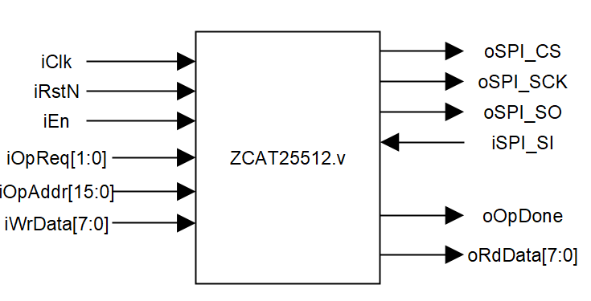 | iClk | IN | 100MHz Clock Input.
 | iRstN | IN | Active Low.
 | iEn | IN | Keeps HIGH during operation period until oOpDone becomes HIGH.
 | iOpReq[1:0] | IN | 2’b00: Write Request.  2’b01: Read Request.
 | iOpAddr[15:0] | IN | Write or read address,  Range: 0x0~0xFFFF-1
 | iWrData[7:0] | IN | Data write into specific address.
 | oRdData[7:0] | OUT | Data read from specific address.
 | oOpDone | OUT | Operation done signal.
 | oSPI_CS | OUT | Route to Top Layer, connect to physical IC.
 | oSPI_SCK | OUT
 | oSPI_SO | OUT
 | iSPI_SI | IN

- Timing
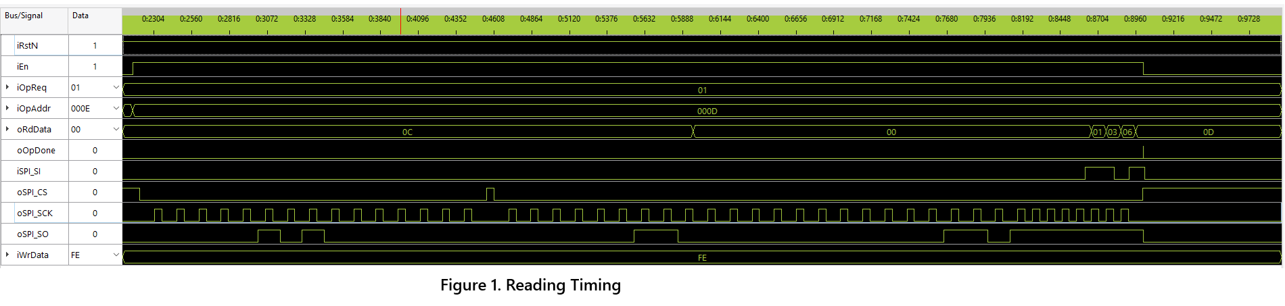
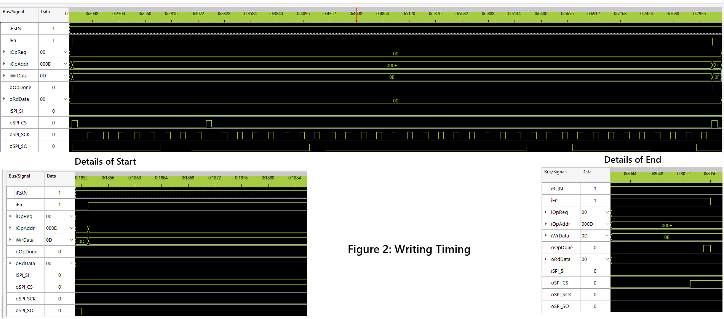

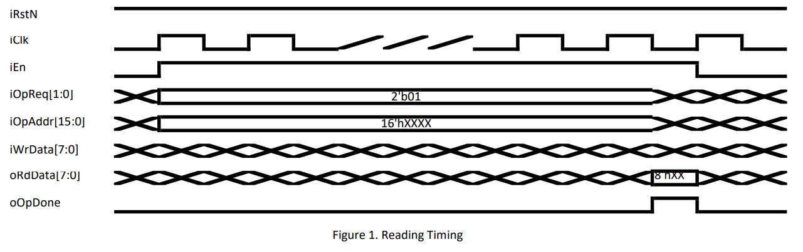
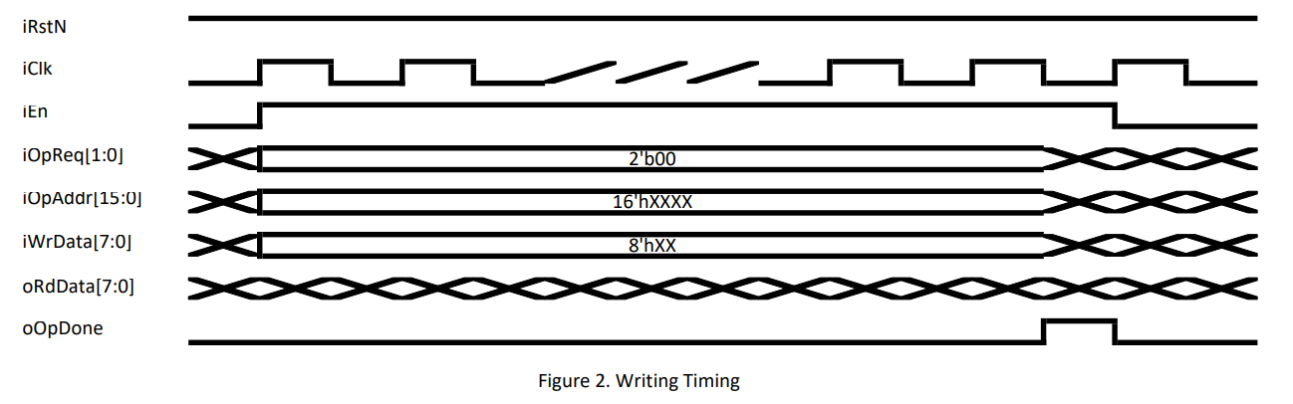

- Module Working Principle Brief Description
This module supports SPI compatible EEPROM operating, includes reading and writing. All signals must meet the requirement in Timing diagram. iEn must stays in HIGH during operating period until oOpDone becomes HIGH. Only byte read/write are supported in this version. Burst operation will be provided in next upgrade. Make all input signals ready before pulling up iEn, and keeps them steady during operation. Pull up iEn to start, oOpDone will be pulled up for only single pulse to indicate operation finishes. Once oOpDone is HIGH, pull down iEn immediately.
Since the maximum clock frequency of SPI clock is 5MHz, this module divides the input clock by 50, the ultimate operation frequency is 2MHz.

- Pin Constraint Contents
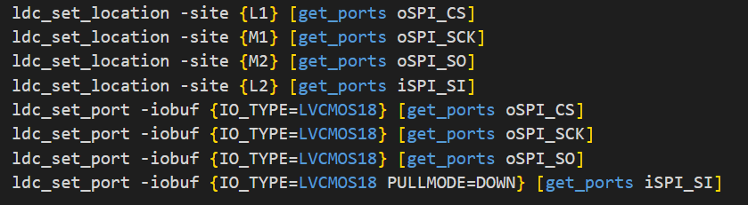

CAUTION!!!
Official specification shows CAT25512 chip only has 1,000,000 Program/Erase Cycles !!!
Continuously Writing the same address will cause cells damaged permanently !!!
Balanced Writing Strategy can be used in top design to extend chips lifecycle.

